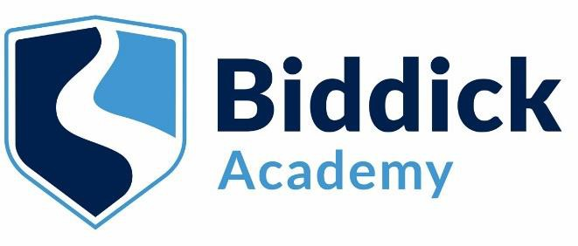

Biddick Academy Access Fund Application

Information for Parents and Carers

What is the Access Fund?
The Access Fund is a discretionary source of financial help available to all registered students. The aim of the fund is to help students who have difficulty in paying for:
- Curriculum trips and visits
- Uniform, shoes or PE Kit
- Other materials or equipment required for their academic studies
- Expenses to attend seminars, interviews or work experience placements
- Emergency travel expenses

Payments from the Fund are discretionary and if awarded do not need to be repaid. Who can apply?
The Academy will consider applications from the following groups of students:
- students living alone outside the family home
- students in receipt of free school meals
- students in families with very low incomes
- students with disabilities
- students who are or have been in care/foster care
- students who have been subject to other exceptional circumstances Your children may be eligible for grants from the support fund if:
- A household income of below £25,000
- A student whose parents are currently claiming other means-tested benefits including Income Support, Working Tax Credit/ Child Tax Credit, Income Based Employment and Support Allowance (ESA), Universal Credit
- At the decision of the Headteacher, any student who does not fall under the categories listed above, but consider themselves to be in financial hardship

As there are only limited funds, we have to make sure that grants reach those most in need of support. The more information that you can provide regarding your circumstances, whether they are long standing or short term, can help us decide how the funds should be most suitably distributed.

What evidence is required?

We don’t formally ask for evidence for this application, a completed application form that details the family circumstances and household income is usually all that is required to make a decision. We might contact you for more information. All forms, correspondence and communication is dealt with in the strictest confidence by the Director of Business & Finance (Mr Carr).

How to apply to the Access Fund

An application form for the type of support required, along with a letter detailing the family circumstances should be made through the Director of Business & Finance (Mr Carr). The application will remain confidential and will be considered by senior staff given their knowledge of the student’s circumstances. If approved the application will be authorised, verified and transaction completed.

Please complete the attached application form and send to Mr Carr via the email address below, or alternatively contact Mr Carr to obtain a paper copy.

access.fund@biddickacademy.com

Biddick Academy Access Fund Application

Your Details – Please complete in capital letters

Title: | Miss, Ms, Mrs, Mr or Other
Surname or Family Name:
First Name:
Partner’s Surname (if applicable):
Partner’s First Name (if applicable):
Address:
Postcode:
Telephone:
Email address:

Children you are applying for

Name of child | Form Group and Year | Date of Birth | Gender (M or F)

Please detail how your circumstances meet the criteria:

Please detail the support you require for your children:

